Test macro

$a = (Get-MpPreference).AttackSurfaceReductionRules_Actions
$i = (Get-MpPreference).AttackSurfaceReductionRules_Ids
$c = 0; while($c -lt $a.count) { $i[$c].ToString() + ": "+ $a[$c++].ToString() }

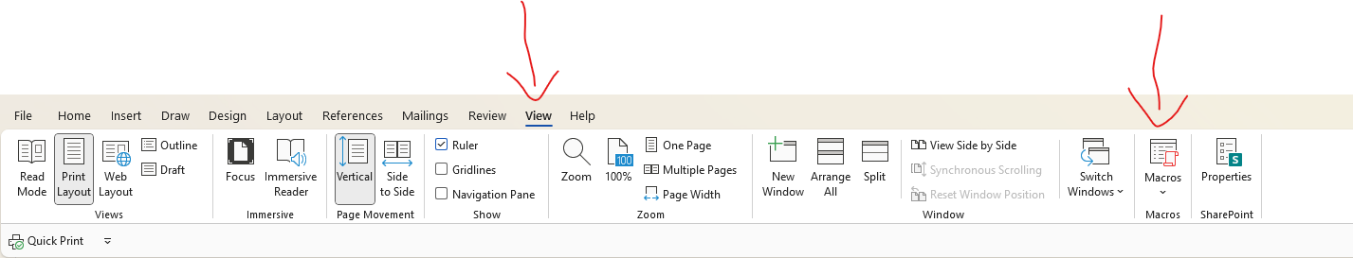

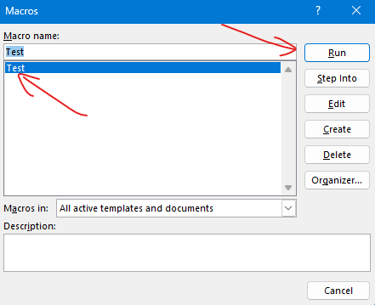

Verwendetes Test-Macro:
